STUDENT RESULT MANAGEMENT SYSTEM

The main objective of this project is to provide the examination result to the student.

There are three users of this system, they are as follows:

1. Admin : He/she (admin) is a super user who enjoys all the privileges. Admin can add/update/delete semesters, subjects and their full marks. Admin also have the right to approve/disapprove teacher/student account who have registered to this system.
2. Teacher : Teacher is required to create an account and then gets approved by the admin. Teachers can view the list of students assigned to them(automatically shows the student list of the same semester). Teacher can add/update/display/delete marks for the semester’s all subjects added by the admin. Teacher can edit his/her profile details and can also upload his/her profile pic.
3. Student : Student is required to create an account and gets approved by the admin. Student can view his/her result uploaded by the teacher. Student can also edit his/her profile and upload profile pic.

**To implement this project, follow the steps below:**

STEP 1:

Download Code and copy to root directory of localhost.

STEP 2:

Create database with name *student_result_management.*

STEP 3:

Select created database and import data from *student_result_management.sql* file. This file located inside *sql* folder inside your downloaded folder.

STEP 4:

Now run *index.php* file from localhost.  
Eg. <http://localhost/student> result management/index.php

By visiting *index.php* you can see the below page. Where teachers/students can register themselves.

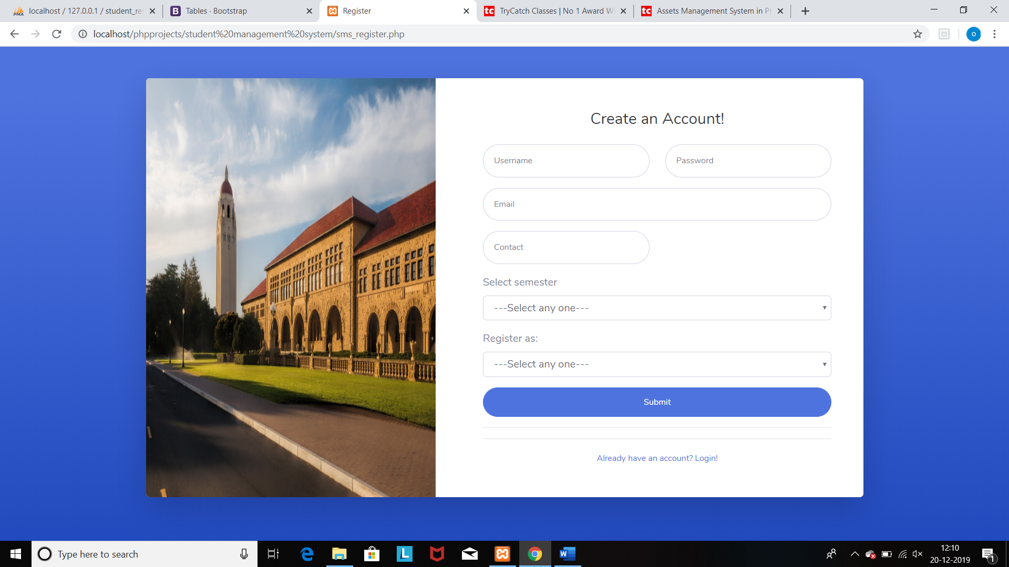

#### **STEP 5:**

Admin Login with**Username : *admin* | Password : *admin123***

Teacher Login with**Username :*teacher1* (registered username)| Password : *teacher123***

Student Login with**Username : *student* 1(registered username)| Password : *student123***

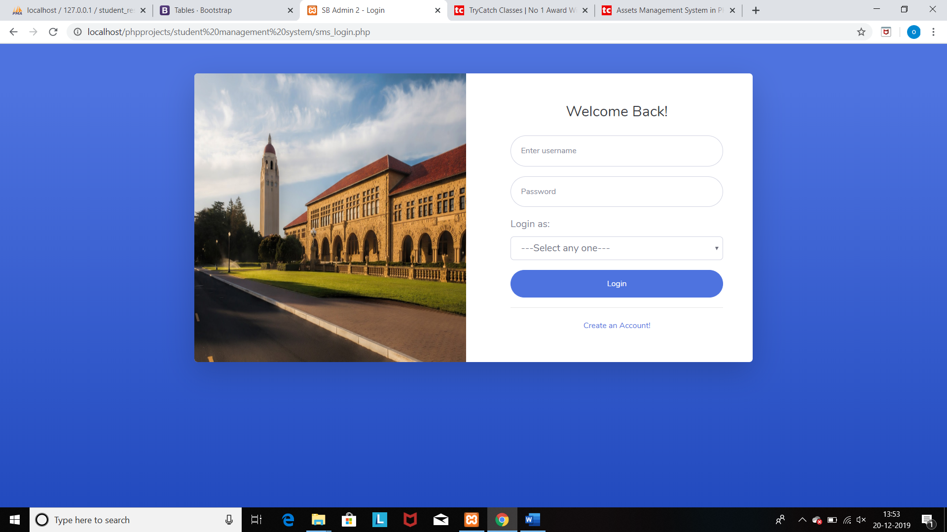

#### **STEP 6:**

**On admin login:**

**You can see the admin main page and admin dashboard. On admin main page you can see the registration details.**

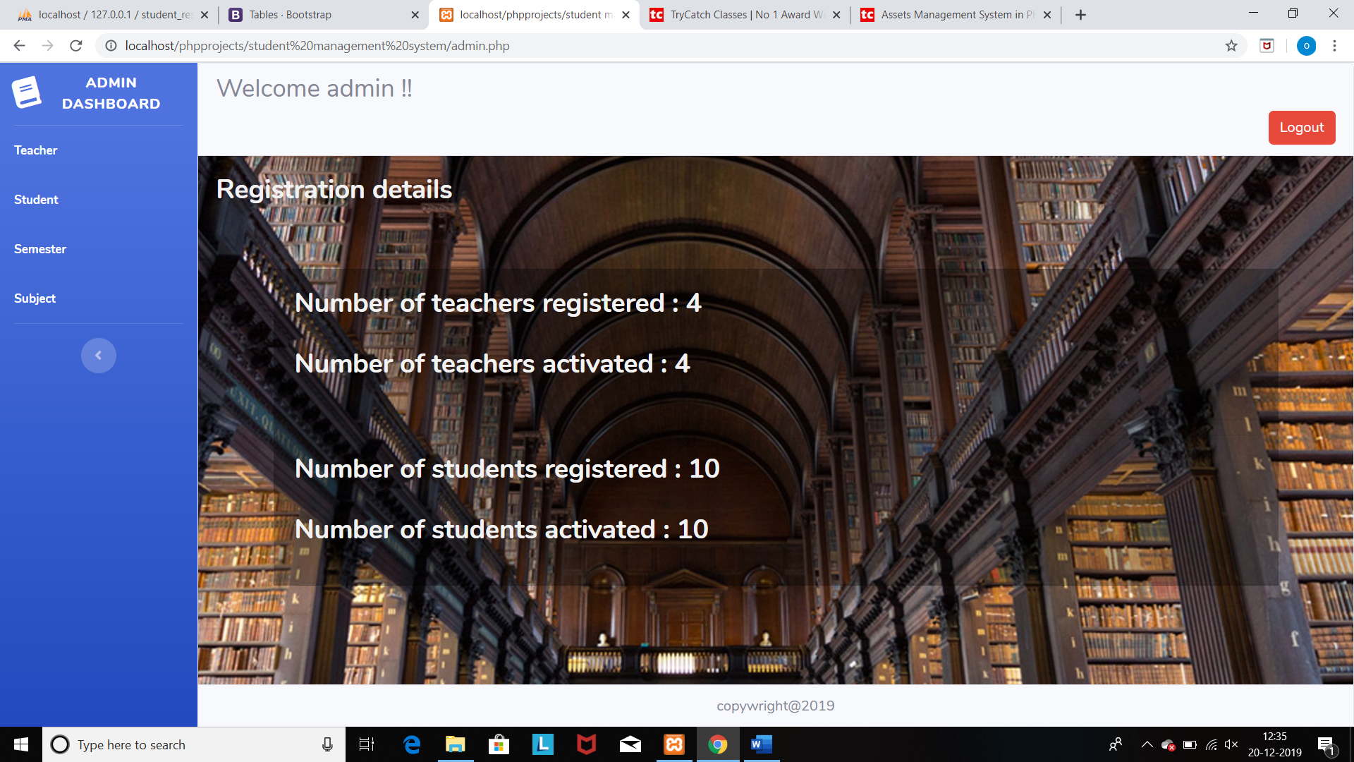

**Admin dashboard:**

**Teacher: On this page admin can see the number of teachers who have registered and the admin can update the status of each teacher(active/deactive). Admin can also delete the record of teacher.**

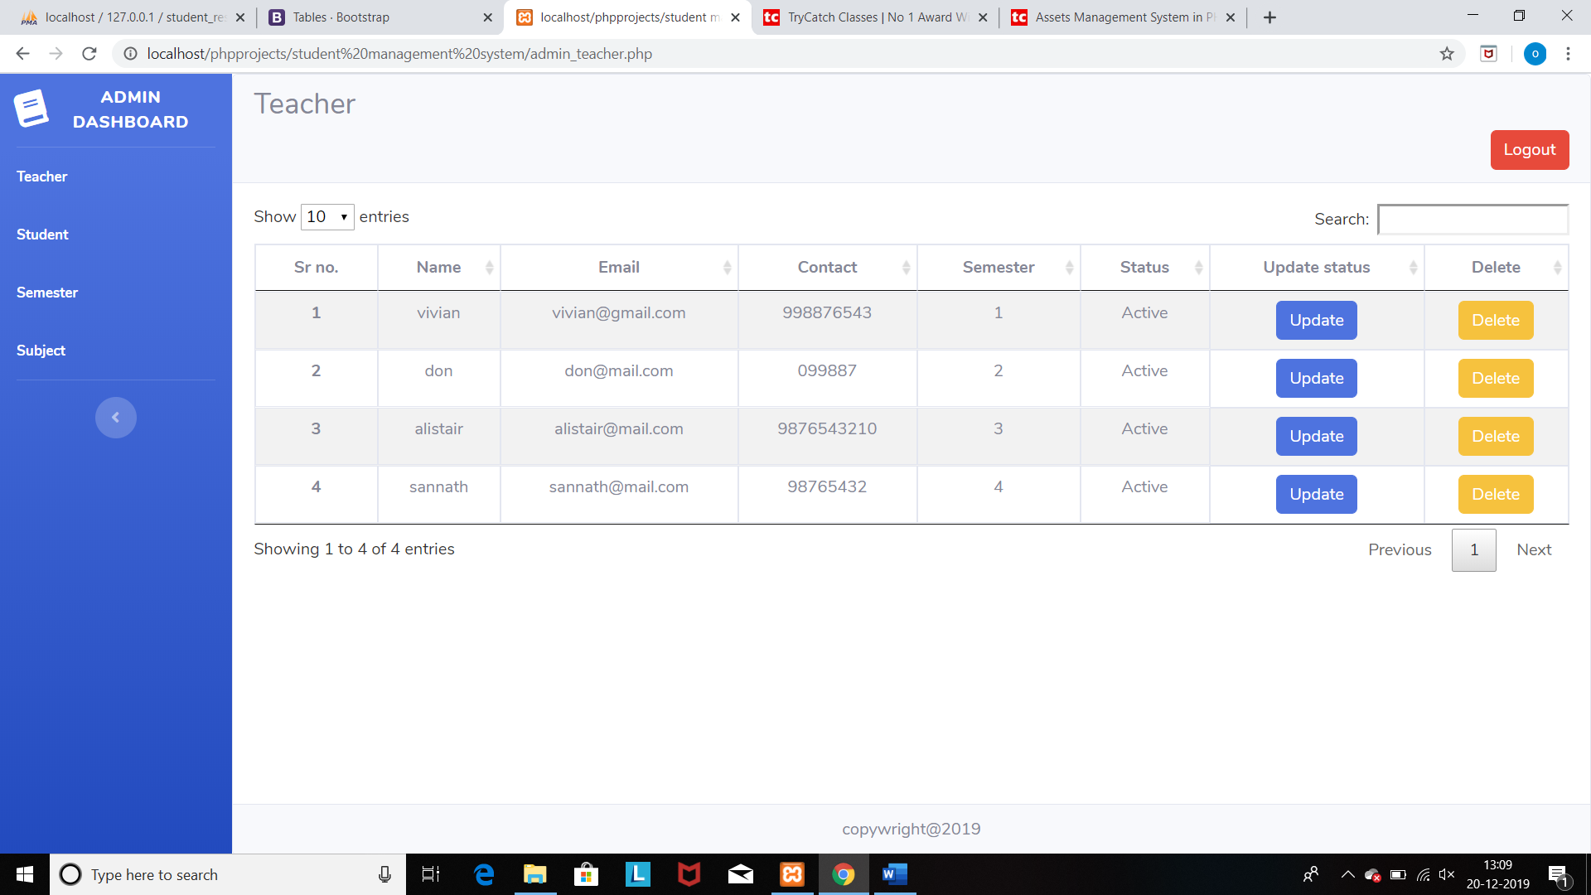

**Student: On this page admin can see the number of students who have registered and the admin can update the status of each student(active/deactive). Admin can also delete the record of student.**

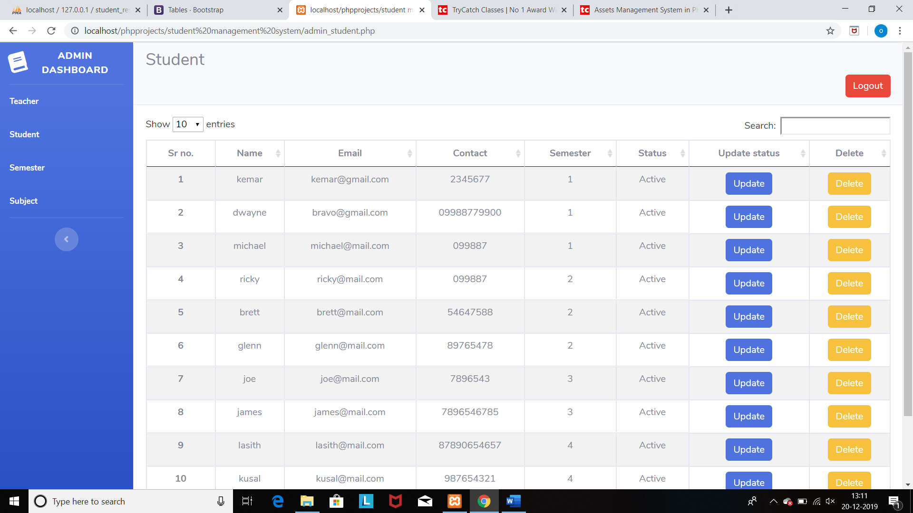

**Semester: On this page admin can add/update/delete number of semesters.**

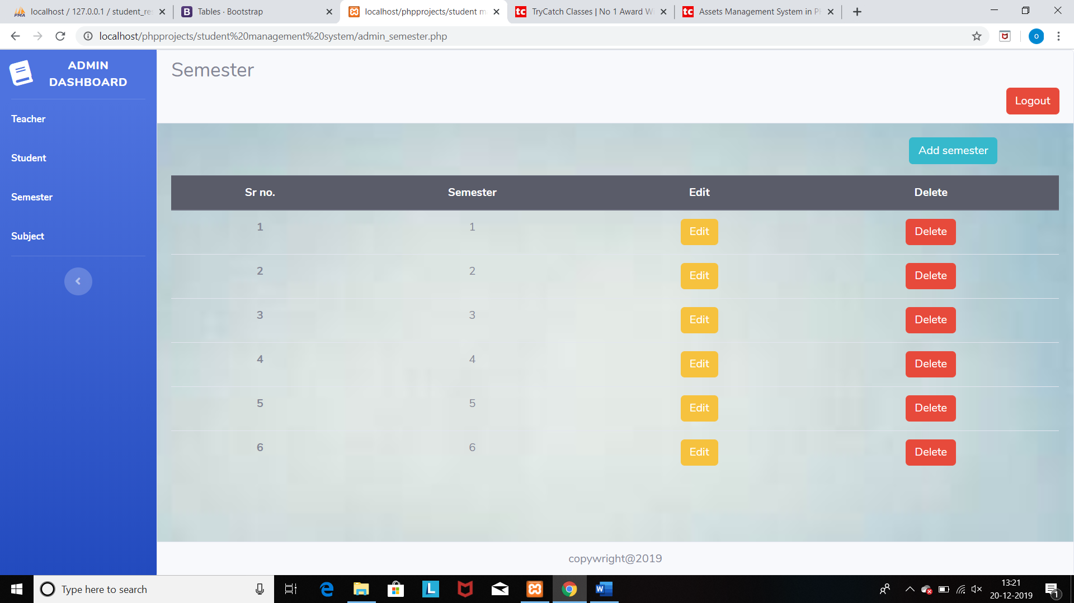

**Subject: On this page admin can add/update/delete number of subjects along with their full marks.**

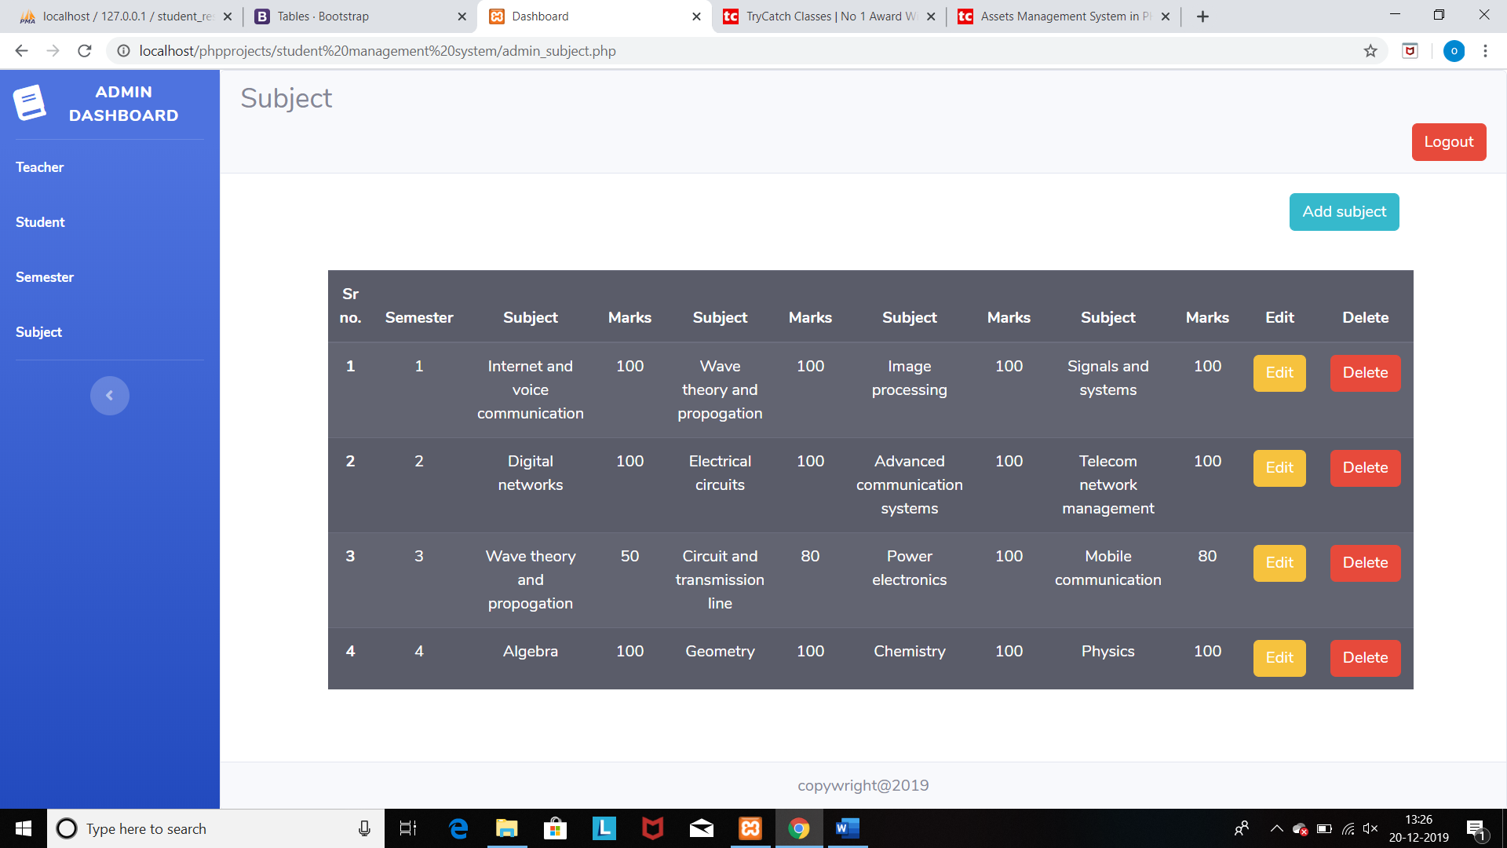

**On teacher login:**

**You can see the teacher main page and teacher dashboard. On teacher main page teacher can see his/her profile details and profile pic and can edit his/her profile details.**

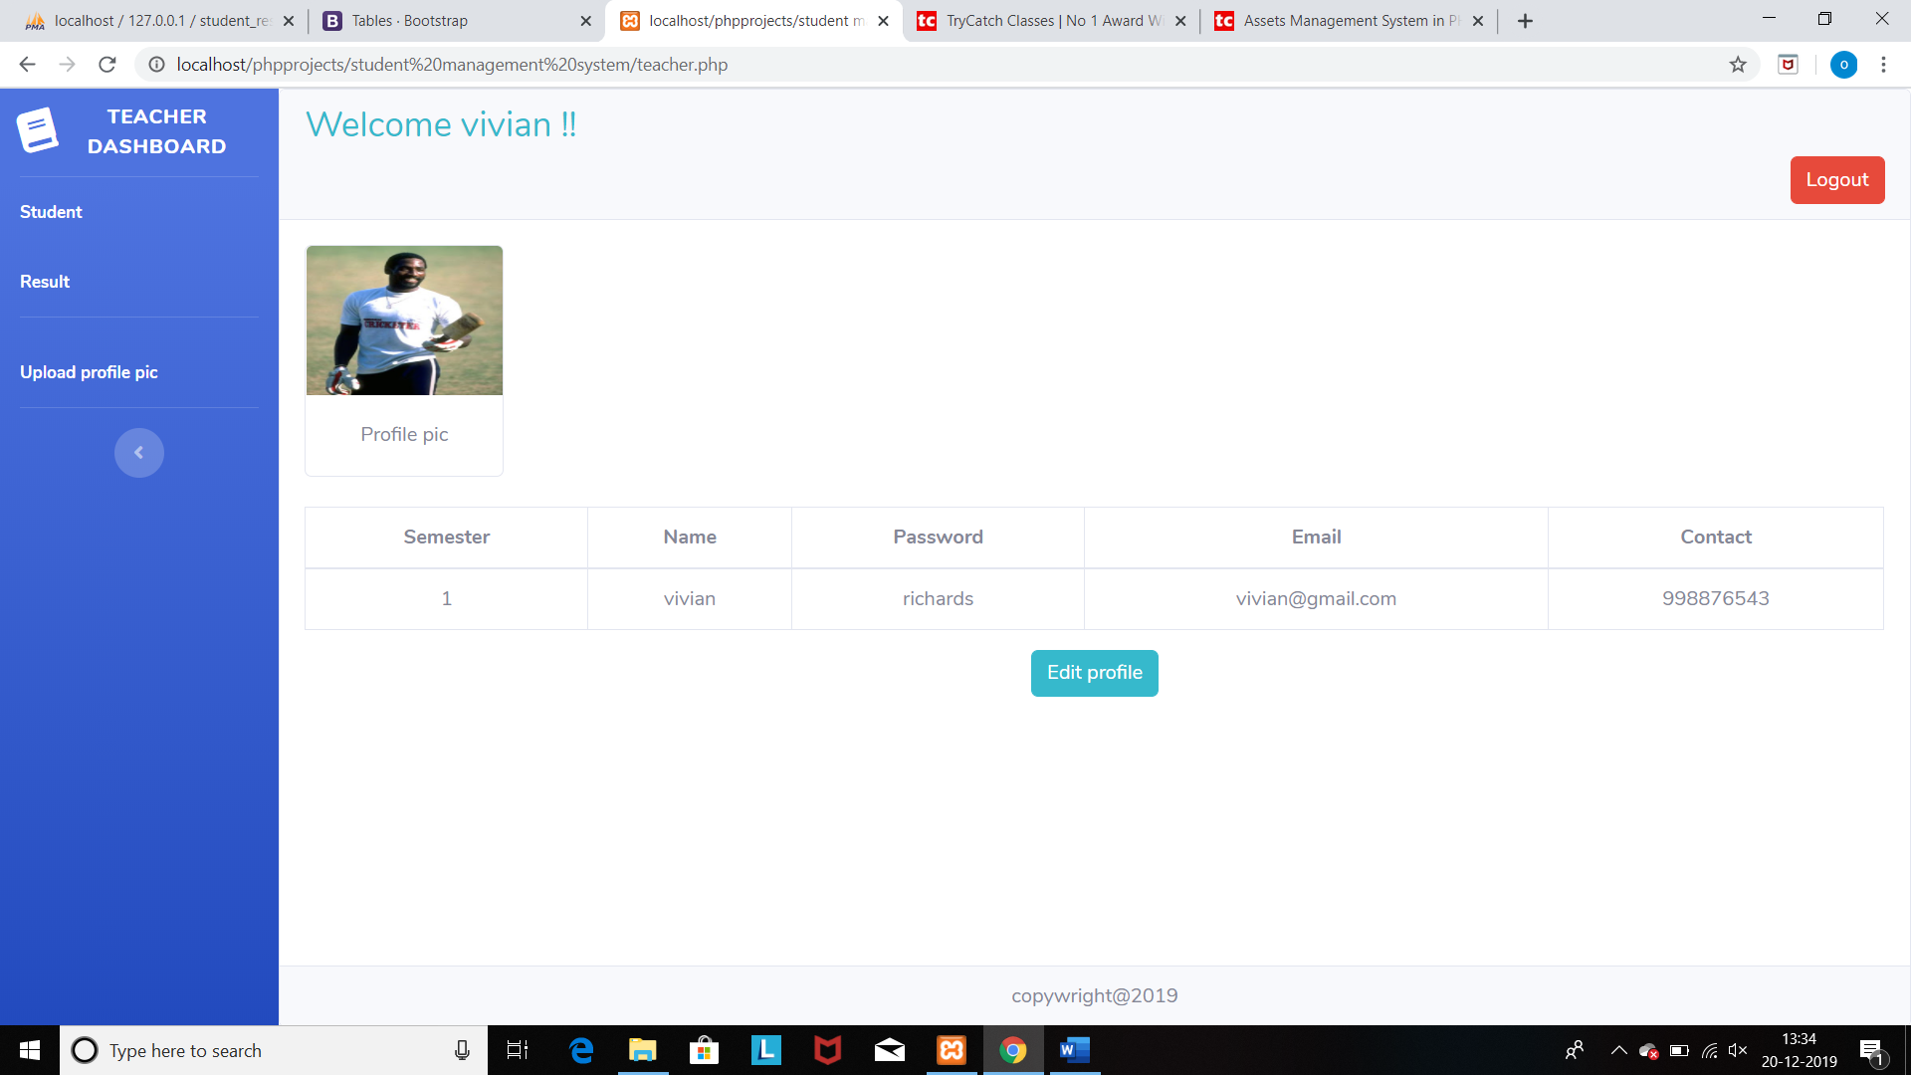

**Teacher dashboard:**

**Students: Here the teacher can see the record of students who have registered with same semester as of teacher.**

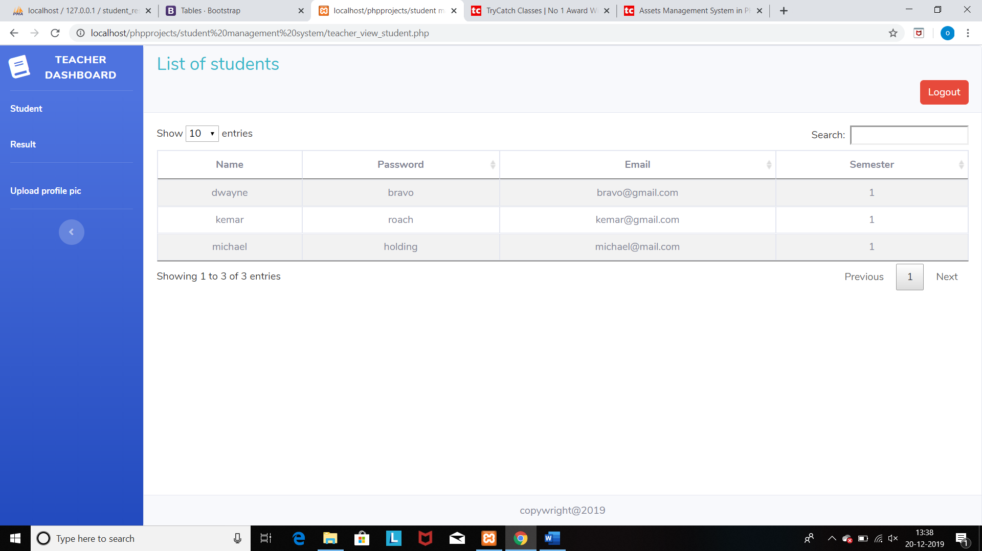

**Result: Here the teacher can add/update/delete results of students.**

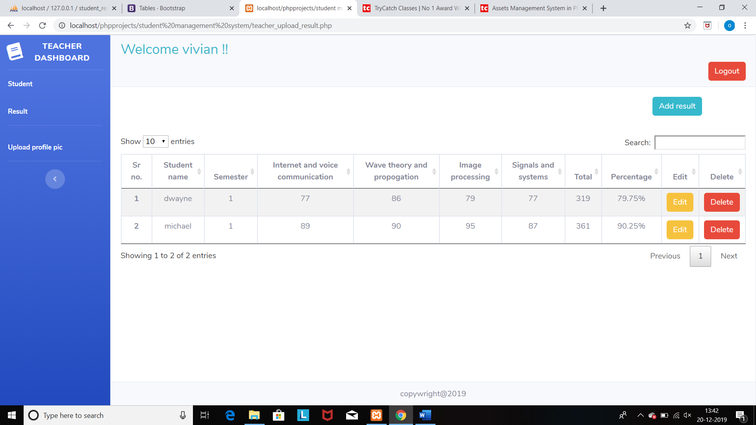

**On student login:**

**You can see the student main page and student dashboard. On student main page student can see his/her profile details and profile pic and can edit his/her profile details.**

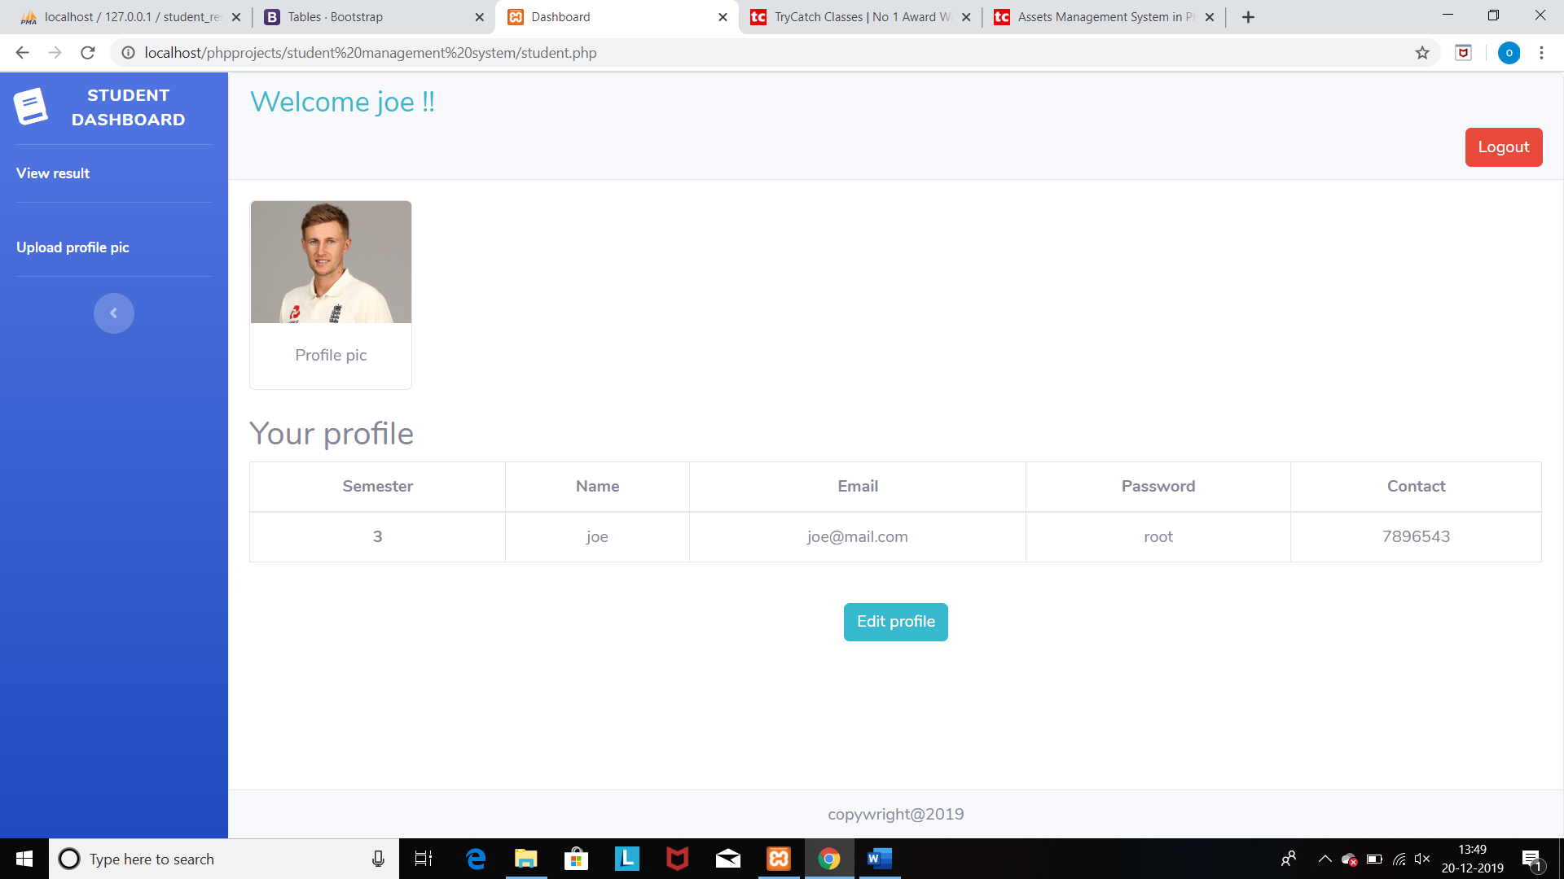

**Student dashboard:**

**View results: Here the student can view his/her result.**

